37, Design NFA using simulator to accept the string that start and end with different symbols over the input {a,b}.

INPUT:

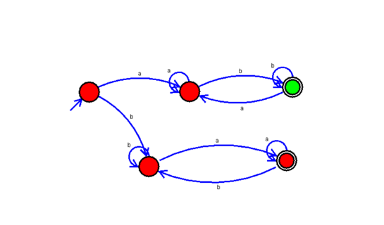

OUTPUT:

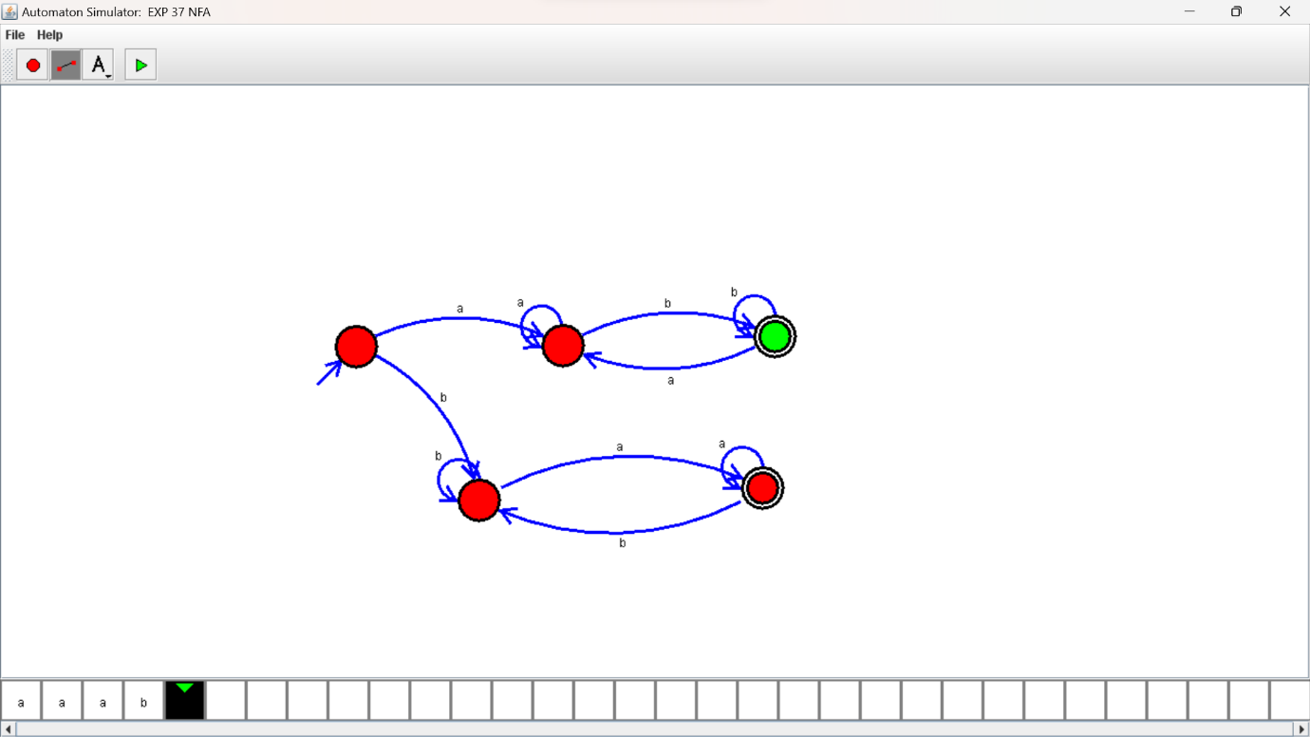

RESULTS:

NFA using simulator to accept the string that start and end with different symbols over the input {a,b}.